Name: **ZOHAIB HASSAN SOOMRO**

RollNo#: **19SW42**

Subject: **DBS**



1. Create a table named BOOKS that will have 4 columns as:
   1. Book_ID with NUMBER data type. (Also PK)
   2. Book_Name with varchar data type and length 30.
   3. Author_ID with NUMBER data type.
   4. Book_Isbn with varchar data type and length 30.

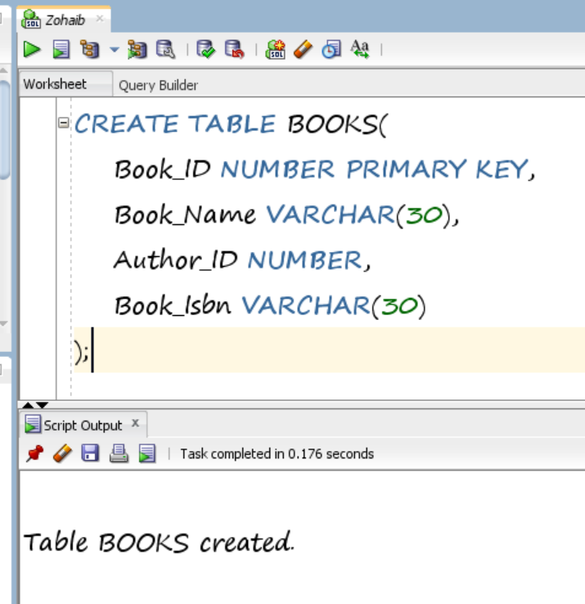

1. Add not null on Book_Name

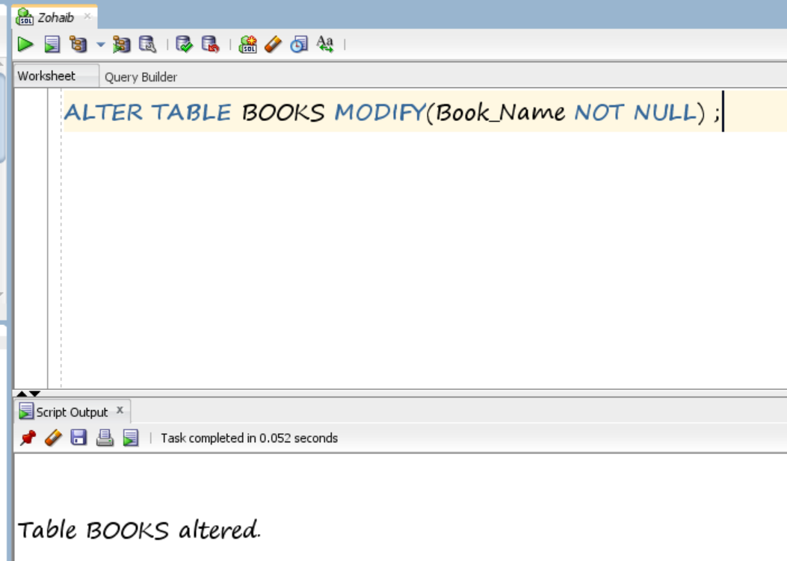

1. Add check on Book_Isbn so that isbn is not null and unique

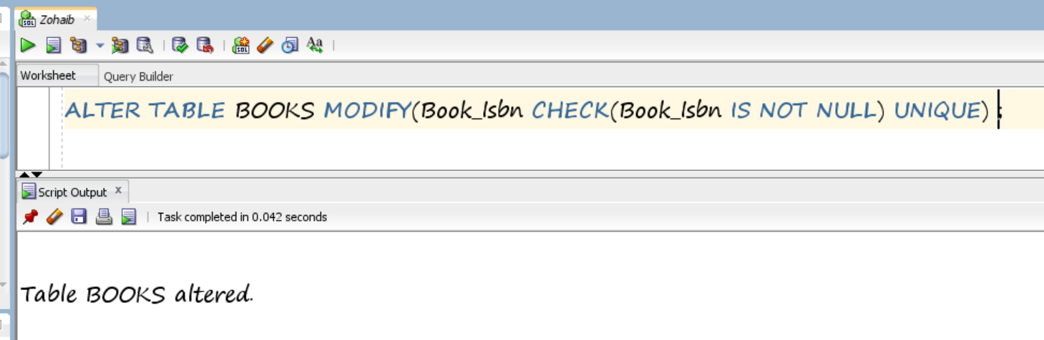

1. Create a table named AUTHORS that will have 3 columns as:
   1. Author_ID with NUMBER data type. (Also PK)
   2. Author_Name with varchar data type and length 30.
   3. Author_Publications with varchar data type and length 20.

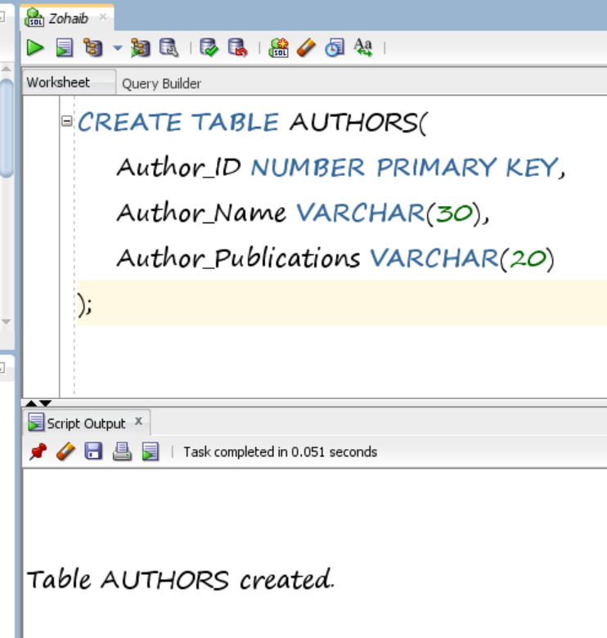

1. Add a foreign key between table BOOKS and table AUTHORS.

